Today’s Lecture Road Map
Dated: 28th May 2021
Data Management (Android)
Storage Options:
- Language specific
- Key value Storage
- Core data Storage
- Network Based Storage

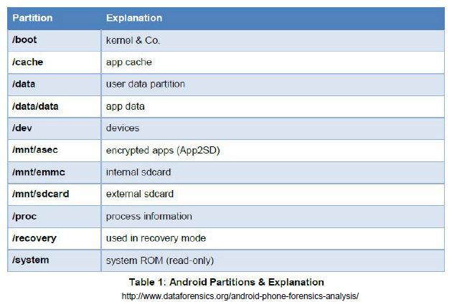

Android Storage
- Language Specific: FileInputStream and FileOutputStream
- Key-Value: SharedPreferences
- Core Data: SQLite DB built into every app
- Network: Web services, network DBs, etc.

https://developer.android.com/guide/topics/data
in IOS: (Overview)
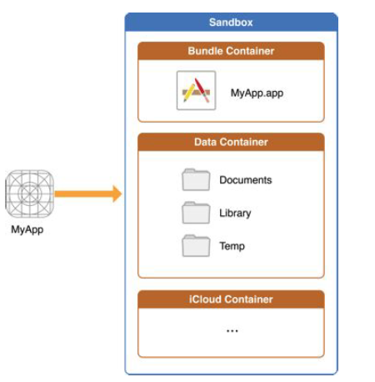

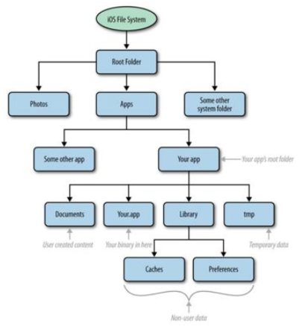
The File System
- .app – this is your app (inside the .ipa), but it’s a folder
- Documents – for user-created content
- Library – for cached files, preferences, etc. (but usually holds folders that holds each of these
- Library/Application Support– save your data here because this is backed up by iOS!
- tmp – for all the files that don’t need to be backed up

- Just like with Android, there are some instances where a flat file just won’t cut it, so in Android, we instantiated our own SQLite DB. We can do the same in iOS however, it’s wrapped in its own specific API called Core Data
Core Data
- Core Data is a managed object model
- create a class that represents an object
- declare how that data is represented in data store
- We can specify its relationship to other models it is very much like MVC
- If we weren’t using a separate library, we’d just call these models “tables” in a DB sense
Using Core Data
1. Add it to the project at creation time. This will auto-generate a lot of code for you and link in the proper library
2. Setup your model code (class)
3. Setup your model in the .xcdatamodeld
4. Import the framework

Flat files could be for:
- Simple preferences
- Notes / data files
Core Data could be for:
- Multiple entries of the same object (i.e. songs, locations, people, addresses, etc.)
- More complex preferences
- Local store for offline data usage

Data Sets:
Think of some data sets that are on your phone/mobile device?
- Large sets?
- Small sets?
- Sets that have to be shared between apps?
● We typically want our mobile experiences to be more “unified” across data sets

Why do you think this is the case with mobile more than desktop? Or do we just not expect it yet with desktop?
● For mobile:
- It’s harder to enter / retrieve data with a limited input device.
- You are typically going for speed / ease of use.
- Users picture their mobile device as a cohesive unit, not a “computer”.
- “Personal Digital Assistant”

Most basic data we manage for an app – assets.
- Assets are any piece of data or content that is built-in with the app and is required for the app to run.
  - Images
  - Sound
  - Pre-written text
  - In general, all content

Size limited by assets. ● Max app sizes:
- iOS: 4GB (up from 2GB in 2015) with a 100MB over-the-air (OTA) limit
- Android: 100MB (up from 50MB in 2015) with up to 2 2GB “expansion files” to contain the assets

What affects app sizes?
Well, it’s not really the code… most .apks pretty easily fit in the 100MB Android build.
- Image assets are a huge culprit
  - Hi-res images for all different screen sizes and resolutions
- Audio and Video
  - Can be huge if you have localized audio and thus multiple copies.

Storing Data:
- Assets are all stuff that comes built-in with the app.
- The user doesn’t have a choice or say in it being installed and taking up space.
- However, many apps that you’ll want to create have some notion of saving data in some capacity.

What are some things a user might want to store in / from an app you create?
- Simple information
  - Preferences
  - Login information
  - Basically key-value pairs
- Complex information
  - All your content

Storage Options:
- Language-specific storage (i.e. roll-your-own)
- System key-value store
- System core data store
- Network-based storage

- Language Specific
● In Java or Swift, how do you write to a file?
● What does that file look like?
● Where do we store the file?
○ In our sandbox model, all files like this need to be stored in the app’s user directory
○ This does not really promote unified data (if your app is something that would benefit from this)
○ Content Providers, Services, etc. are ways to address this

- System Key-Value
● Both OSes have the capability to let you store very simple information in a centralized data store
● Does have some protections on it
● Mostly limited to just your app (i.e. some permissions can affect this)
● Typically used for permissions, logins, other simple information

- System SQL Lite
● Your own file creation and system based key-value stores don’t quite cut it for most data you want to store from an app
● A lot of data probably looks like stuff you would store in a database
● iOS and Android each have built-in mechanisms for internal Databases

- Network Storage
● Data on your device is fine… but usually we want our apps to interact with others or provide the ability to interact with data in other ways
● We can interact with database servers, or even better, web services to manage our data

Storage Options
● None of these options are mutually exclusive!
● Often the key-value is used for preferences and the core data store is used for created content
● There’s also a fifth option…
● For instance, if you create data that can be stored by another app (like a photo for your photo library)
● How do we choose? How do we plan our data storage options?
● How much do we have to decide early?

